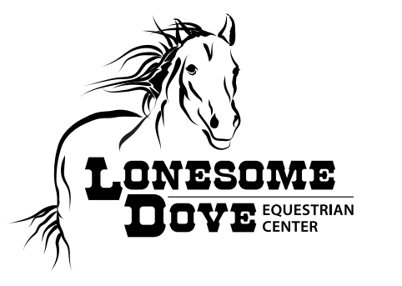
“Heroes, Horses, and Healing: You are Mission Critical”
September 5th, 2020 @ 12pm-3pm
Lonesome Dove Equestrian Center
6137 Old Buckingham Road, Powhatan, VA 23139
Vendor Registration Form
Business Name: ____________________________________________________
Contact Name: ____________________________________________________________
Mailing Address: _________________________________
City: _______________ ST: ______ Zip: _____________
Phone: ______________ Cell: ___________
Email: _________________
Number of people attending__________________________________________
Purpose of event: Raise awareness of services that benefit veterans, service members, and their families and caregivers. Increase military cultural competency of providers.
Vendor fee: NONE! Bring a door prize for the raffle.
Environmental conditions: Indoor/Outdoor event, rain or shine. Vendor setup is indoor, DIRT floor riding ring. Wear appropriate clothing.
Set up: Tables and chairs are not provided. There is room for 15 tables, so space is limited!
COVID19 Safety Precautions: Please maintain at least 6 feet of distance between other vendors and wear a mask.

Submit registration form to rpentecost@goochlandva.us. If you cannot attend, please email if you would like your pamphlets or business cards shared at the event or would like to help in another way.

